

Tribhuvan University

Faculty of Humanities and Social Science

E-commerce Website

A PROJECT REPORT

**Submitted To**

Department of Computer Application

Shahid Smarak College

*In partial fulfillment of the requirements of the Bachelors in Computer Application*

**Submitted by: -**

Amir Maharjan (2620200)

**Acknowledgement**

I extend my heartfelt gratitude to the supervisor Hari Lal Chalise who played a pivotal role in the successful completion in building this e-commerce website. His unwavering support and contributions have been instrumental in bringing this project to fruition.

I am deeply thankful to my project supervisor for his guidance, mentorship and invaluable insights throughout the project’s lifecycle. His expertise has been a guiding light that shaped the project’s direction. We also want to acknowledgement our families, whose unwavering support, understanding, patience were the pillars sustained throughout this project’s journey.

Lastly, this project has been collaborative effort, and I am proudly grateful to everyone who contributed in any capacity. The knowledge gained and lessons learned during this project will guide me in my future.

**Abstract**

The cutting-edge online retailer ShopSwiftly provides customized product recommendations based on user tastes. A hassle-free shopping experience across several devices is ensured by its user-friendly UI. Strong encryption and a variety of payment methods put security first. Functionality is improved by the platform's smooth integration with outside programs and services. Updates and upgrades are driven by user feedback and ongoing innovation, guaranteeing relevancy. With easy navigation and a quick checkout process, users may have a well-curated buying experience. Favorite product sharing is made simple with social network integration. By raising the bar for ease of use and client happiness, ShopSwiftly hopes to completely transform the online purchasing experience. It provides flexibility and agility to satisfy a range of needs because to its dedication to innovation. Discover ShopSwiftly for a safe, secure, and seamless online buying experience.

**Table of Contents**

Chapter 1: Introduction 1

1.1 Introduction of the project 1

1.2 Problem Statement 1

1.3 Objectives 1

1.4 Scope and Limitation 1

Chapter 2 Background study and Literature Review 2

2.1 Background study 2

2.2 Literature review 2

Chapter 3: System Analysis and Design 3

3.1 System Analysis 3

3.1.1 Requirement Analysis 3

3.1.2 Feasibility Analysis 4

3.2.1 Architectural Design 5

Chapter 4: Implementation & Testing 7

4.1 Implementation 7

4.1.1 Tools used 7

4.1.2 Implementation details of modules 8

Chapter 5: Conclusion & Future Recommendation 10

5.1 Lesson Learnt / Outcome 10

5.2 Conclusion 10

5.3 Future Recommendation 10

References 11

# 

# Chapter 1: Introduction

## **1.1 Introduction of the project**

ShopSwiftly is the online shopping destination where convenience and innovation collide. It is a revolution in online shopping, not simply another e-commerce platform. ShopSwiftly is made to meet the demands of consumers in today's fast-paced world for convenience, simplicity, and dependability in their purchasing experiences.

Our platform offers a smooth and user-friendly layout that guarantees a hassle-free experience from beginning to end, with the goal of streamlining the entire buying process. ShopSwiftly offers a carefully curated collection of products catered to your tastes and interests, whether you're looking for the newest styles in fashion, basic household equipment, or unusual presents for your loved ones.

## **1.2 Problem Statement**

Travelers have a hard time coming to a decision. They have to overcome many hurdles.

* Users cannot find best and affordable products.
* Users would have to manually visit the store.

## **1.3 Objectives**

* To provide convenience for customers to shop anytime, anywhere
* To offer unique products and competitive pricing for a competitive advantage

## **1.4 Scope and Limitation**

**Scope**

* Can overcome geographical and language barriers.
* Can host an extensive array of products

**Limitation**

* Vulnerable to cybersecurity threats
* Relies heavily on technology infrastructure.

# Chapter 2 Background study and Literature Review

## **2.1 Background study**

This project is rooted (unlikely to be easily changed) in the dynamic and evolving travel industry. With the arrival of digital technology, users gradually rely on online platforms to buy and sell their wanted and unwanted products. This project seeks to address the growing demand for a comprehensive and user-friendly online platform that streamlines buying and selling, enhances user experiences, and integrates various e-commerce services seamlessly.

During the research phase of the project, we came across many websites that we could take as references. Daraz, a well-established e-commerce business was one of them. It’s a great platform to buy products from. It is constantly giving out discount coupons and amazing offers. We can also order products as a guest. But the biggest drawback of it, is that the UI is not very good and is very hard to navigate throughout the system.

## **2.2 Literature review**

In reference [1]: SastoDeal is another prominent e-commerce website in Nepal known for offering discounted deals on a variety of products and services. Literature on SastoDeal emphasizes its impact on consumer behavior and purchasing patterns, particularly among price-sensitive consumers. Studies explore the effectiveness of SastoDeal's marketing strategies, including deal promotions and flash sales, in driving traffic and sales on the platform.

In reference [2]: HamroBazar is a popular online classifieds platform in Nepal, facilitating buying and selling of new and used items. Research on HamroBazar focuses on its role in enabling peer-to-peer transactions and the challenges associated with ensuring trust and reliability in online transactions. Studies also examine user satisfaction and trust factors influencing engagement on the platform.

# Chapter 3: System Analysis and Design

## **3.1 System Analysis**

"System analysis" is the process of breaking down a system to improve it using better procedures and techniques. This process involves planning a new system to either improve or replace an existing system. Thus, it is the process of gathering and analyzing data, recognizing problems, and applying the data to provide feedback on system modifications.

When conducting a system analysis, the following objectives are kept in mind:

* Perform economic and technical analysis.
* Assign responsibilities to the database, hardware, software, and other parts of the system.

### **3.1.1 Requirement Analysis**

To ascertain the requirements and expectations of a new product, a technique known as requirements analysis or requirements engineering is utilized. It entails regular communication with the product's stakeholders and end users to clarify expectations, settle disputes, and record all essential requirements.

**i*.* Functional Requirement**

Functional requirements are requirement that make up our entire website. For example: a registration form, when a user fills it, the data that is submitted has to be stored in the database in a secure manner.

The system provides the following functionalities:

* Add to cart
* Attractive user interface
* Detailed and competitive pricing

#### **ii. Non-Functional Requirement**

* **Reliability**

System will run 24/7. The data that is submitted won’t be made public or lost when the user logs in next time.

* **Security**

Personal data and information of the user will be stored in a secure manner so that these data and information won’t be hacked or misused.

* **Availability**

The system can be accessed by anyone, anytime and anywhere. What a user’s needs to access the system is a smartphone or a computer or a laptop and a internet connection, that is all.

* **Performance**

Every system needs to perform well in order to be liked by the users. The system is fast, interactive and is easy to use.

### **3.1.2 Feasibility Analysis**

Feasibility means to check if a proposed project or system can be done conveniently or not. A feasibility study is carried out to determine whether the project should (proceed) be done or not. The feasibility of a project is determined by the following: -

#### **i. Technical**

#### Technically speaking, there are no obstacles because all that is needed for the development stage is a functional computer and a reliable internet connection.

#### **ii. Operational**

There are no operational difficulties as well. To operate this system, all it needs is good database connection and a good host.

#### **iii. Economic**

Overall budget can be affected a little bit because of the purchase of database and a host.

**iv. Schedule**

Probably the most important aspect in feasibility study. If a project cannot be completed in time, the project should not even be in consideration. It should be rejected immediately.

**3.2 System Design**

The process of meeting the end-user requirements by designing the architecture, components and interfaces for the system is called system design. The system must be designed in such a way that it meets all of the end-user’s requirements.

### **3.2.1 Architectural Design**

The purpose of this phase is to design how the users will see the system, how the system deals with user inputs and how the data gets stored in the database. All these things are planned and carried out in detail without missing out on anyone of these things.

**Presentation login:** how the users will see the system.

**Business logic:** how the user’s inputs will be handled.

**Database driver:** how the user’s inputs are stored in the database.

The architecture of the application is shown in the figure below.

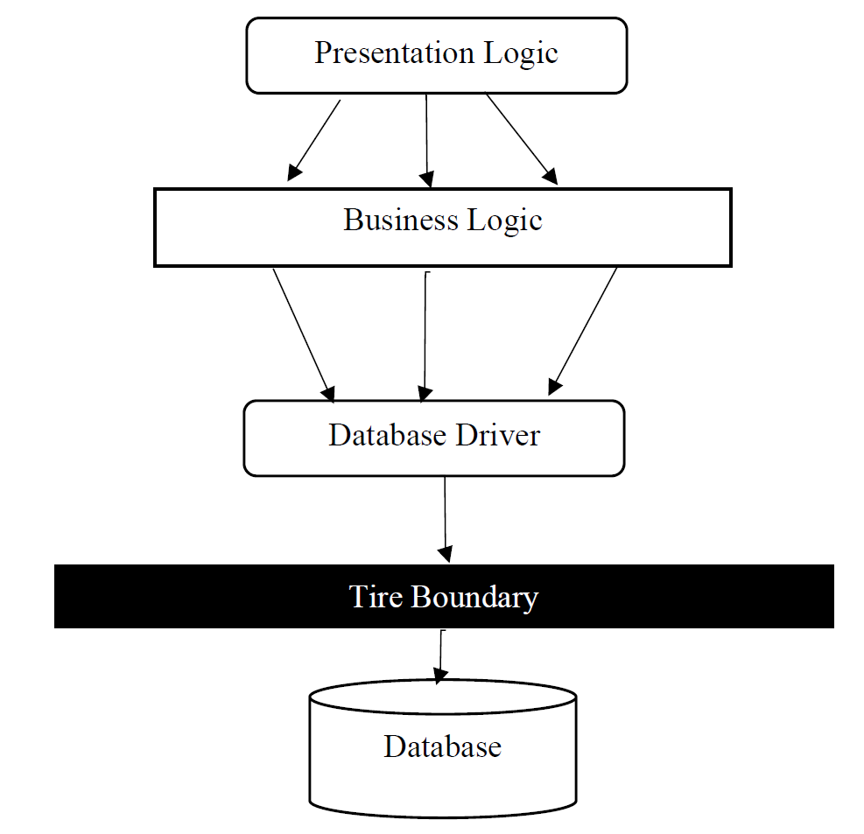

**Figure 1: Architectural Design**

# Chapter 4: Implementation & Testing

## **4.1 Implementation**

Before collaborating with content writers and quality assurance specialists to produce thorough documentation, developers will conduct a final review of the newly implemented system. This means that the development team can now begin getting ready for the product launch.

During the deployment phase, the software development team is ready to collect and evaluate user feedback in order to better understand how their product is functioning and how to improve it in order to boost customer satisfaction.

### **4.1.1 Tools used**

This section describes about the tools used during this project. The tools used are categories into three groups.

**Programming Languages:** The programming languages used in this project.

**Database Platforms:** Databases used in the project.

**Libraries used:** A list of JavaScript libraries used.

**4.1.1.2 Programming Languages**

Programming languages is further divided into two categories frontend and backend which have different set rules and implementation.

#### **4.1.1.2.1 Frontend**

* **HTML**

The Hypertext Markup Language or HTML is the standard markup language for documents designed to be displayed in a web browser. It defines the meaning and structure of web content. It is used in every part of the project as it creates the DOM that makes a website.

* **CSS**

Cascading Style Sheets is a style sheet language used for describing the presentation of a document written in a markup language such as HTML or XML. CSS is a cornerstone technology of the World Wide Web, alongside HTML and JavaScript. CSS is responsible for designing the website.

* **jQuery**

A JavaScript library called jQuery was created to make HTML DOM tree traversal and manipulation, event handling, CSS animation, and Ajax easier. Seventy-seven percent of the 10 million most popular websites as of August 2022 use jQuery. To make the website more user-friendly, we have handled the general behaviors with jQuery rather than with pure JavaScript.

#### **4.1.1.2.2 Backend**

* **PHP**

PHP is an open-source general-purpose programming language that is extensively used, particularly for web development, and can be incorporated into HTML. PHP is an acronym for PHP Hypertext Preprocessor. The servers, databases, etc. are all communicated with via it. Along with ensuring that everything on the client-side functions, it is also in charge of organizing and storing data.

* **AJAX**

Ajax is a set of web development techniques that uses various web technologies on the client-side to create asynchronous web applications. With Ajax, web applications can send and retrieve data from a server asynchronously without interfering with the display and behavior of the existing page.

#### **4.1.1.3 Database Platforms**

* **phpMyAdmin**

phpMyAdmin is a free and open-source administration tool for MySQL and MariaDB. As a portable web application written primarily in PHP, it has become one of the most popular MySQL administration tools, especially for web hosting services. All the data of the website is stored in the database.

#### **4.1.1.4 Libraries used**

* **jQuery**: A JavaScript library. Its motto is “Write Less, Do More”.
* **FontAwesome**: Provides fantastic icons to choose from.

### **4.1.2 Implementation details of modules**

Following the completion of the planning phase, we go on to the implementation phase, when the entire system is broken down into modules in order to reduce effort and find any new faults or issues. The report cannot describe every element of the modules, but it will document the majority of them. Among the modules are a few of these:

* **Esewa integration**

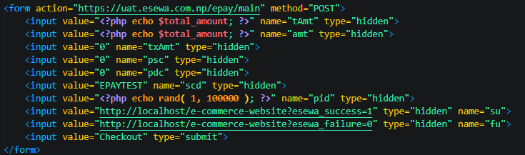

* **Add to cart**

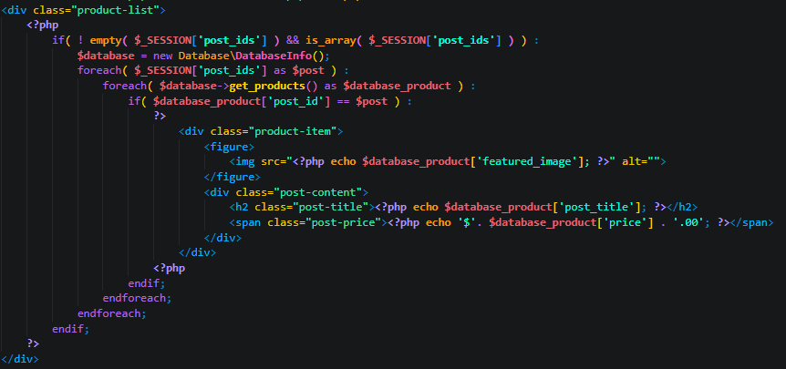

# Chapter 5: Conclusion & Future Recommendation

## **5.1 Lesson Learnt / Outcome**

The project yielded significant insights and outcomes, serving as a valuable learning experience. It provided a comprehensive understanding of e-commerce principles, enhancing technical skills in frontend and backend development. Through self-directed efforts, time management practices were refined, and project management methodologies were explored. Adopting a user-centric design approach, the project emphasized intuitive interfaces and responsive layouts. Testing procedures underscored the importance of quality assurance, while reflective practices facilitated continuous improvement. Overall, the project proved instrumental in personal growth and development, equipping me with practical skills and knowledge applicable to future endeavors in web development and beyond.

## **5.2 Conclusion**

In conclusion, the project has been a significant journey of learning and growth, yielding valuable insights and experiences. Through the development of an e-commerce website, I have gained a deeper understanding of various aspects of web development, including frontend and backend technologies, user experience design, and project management. The project emphasized the importance of collaboration, communication, and problem-solving skills, as well as the ability to adapt to changing requirements and challenges. Furthermore, it highlighted the critical role of testing and quality assurance in ensuring a seamless and reliable user experience. Overall, the project has equipped me with practical skills, knowledge, and confidence that will be invaluable in future endeavors in web development and related fields.

# References

|  |  |
| --- | --- |
| [1] | S. P. Ltd., "Sastodeal," Sastodeal, [Online]. Available: https://www.sastodeal.com/. |
| [2] | HamroBazar, "HamroBazar," [Online]. Available: https://hamrobazar.com/. |